*A Project Report On*

IOT based Time Table Management System

## Submitted for

***Bachelor of Vocation***

## In Internet OF Things

*Submitted By*

#### Shubham Upadhayay

#### Prashant Kumar

*Under the Guidance of*

#### Mr. Ravindra Bhardwaj

#### Mr. Amarjeet Singh Chauhan

***Department of Physics & Computer Science Dayalbagh Educational Institute***

***Dayalbagh, Agra, Uttar Pradesh 282005 February, 2020***

**CERTIFICATE**

This is to certify that the dissertation entitled IOT based Time Table Management System submitted by **PRASHANT KUMAR and SHUBHAM UPADHYAY** in partial fulfillment the requirements for the award of degree of Bachelor of vocation to the Dayalbagh Educational Institute, Dayalbagh, Agra, is a record of his own work carried out under my supervision. The matter embodied in this project has not been submitted for the award of any other degree.

**Dr. R.S. PAVITHR**

**Supervisor**

**Dept. of Physics and Computer Science** **Faculty of Science**

**Dayalbagh Educational Institute**

**ACKNOWLEDGEMENT**

It gives me immense pleasure to express my deepest sense of gratitude and sincere thanks to my highly respected and esteemed Mr. Ravindra Bhardwaj and Mr. Amarjeet Singh Chauhan guide for her valuable guidance, encouragement and help for completing her work. Her useful suggestions for this whole work and co-operative behavior are sincerely acknowledged.

I am grateful to my teacher for their constant support and guiding

**Prashant Kumar**

**Shubham Upadhyay**

**ABSTRACT**

The students in Dayalbagh educational University face a serious problem in viewing their daily classes. Either they have to go through bulky chart papers over the notice boards or through hazy excel sheets on their electronic devices. The process is very tiring and time consuming. Furthermore, looking for your classes and decoding the subject codes, teacher ids, rooms and timings is very gruesome task. TMS – TU aims to solve all these problems with its quick, user friendly interface and smooth functionality. The website mainly has three modules – Admin, Teachers, and Students.

• Admin – Admin manages all the accounts, enter the master time table into database, can register or remove both students and teachers, assigns rooms according to capacity.

• Teacher – The teacher is registered by Admin only. Teacher can look for her own time table from day to day. The teacher can schedule the cancellation of her future classes. The cancelled class will be notified to the students associated with the respective class.

• Student – The students can themselves register on the website. Fill in their details, roll numbers, program, branch, year, group and tutorial group. The system will automatically display their time table properly segregated day-wise. The students can view notifications for any cancelled classes from their faculty.

**INTRODUCTION**

In schools, colleges, universities, we saw a time table of student classes, similarly we create a website which shows weekly time table (using HTML, CSS, JS and PHP) of students, which will shows time table publicly, then we create a Login / Sign up system for Admin only, who will manages the whole database of time table, and also insert, update , delete time table data according to classes

DAYALBAGH EDUCATIONAL University covers a large number of disciplines and programs. As a result, there are varied courses and classes running in parallel. Thus there is always a very complex and huge timetable of the university. The university publishes a common excel file containing the master time table. Each student has to go through lot of toiling to view his own schedule and concerned classes. Moreover because of space constraints, most of the details are in coded form. This reduces the readability of the table. Timetable Management System (TMS) – deemed University (TU) aims to solve this problem in a very flexible and efficient manner. TMS is a web based system which is developed for Teachers and Students of in this as their online Time-table. Once a student registers on the website, he can look into his time table easily on a day-to-day basis. Each semester, he can update his details and stay up to date with the university time table

**Features:**

* Login/Register System
* Admin Panel
* Student account
* Manage Exam and class timetables
* Create Notices
* Manage Schools, department, students

# 

# Components:-

**Hardware: -** Raspberry-Pi, Monitor.

**Software: -** XAMPP,

# XAMMP:-

XAMPP is an open-source web server package that works on various platforms. It is actually an acronym with X meaning “cross” platform, A for Apache HTTP server, M for MySQL, P for PHP, and P for Perl. XAMPP was designed to help webpage developers, programmers, and designers check and review their work using their computers even without connection to the web or internet. So, basically XAMPP may be used to [stand](http://www.qwhatis.com/what-does-hvac-stand-for/)as pages for the [internet](http://www.qwhatis.com/what-is-internet/)even without connection to it. It can also be used to create and configure with databases written in MySQL and/or SQLite. And since XAMPP is designed as a cross-platform server package, it is available for a variety of operating systems and platforms like Microsoft Windows, Mac OS X, Linux, and Solaris.

To use XAMPP, only one zip, exe or tar [file](http://www.qwhatis.com/what-is-eps-file/)is needed. Users just need to download this [file](http://www.qwhatis.com/what-is-dmg-file/)and run the application. There is also not much configuration and tinkering to be done in terms of settings and its components. The XAMPP package is also updated on a regular basis to synchronize with the updates made on the different platforms involved in the package like Apache, PHP, Perl, and MySQL.

# Respberry Pi:-

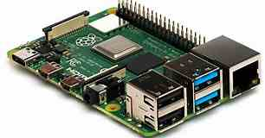

The Raspberry Pi is a low cost, **credit-card sized computer** that plugs into a computer monitor or TV, and uses a standard keyboard and mouse. It is a capable little device that enables people of all ages to explore computing, and to learn how to program in languages like Scratch and Python. It’s capable of doing everything you’d expect a desktop computer to do, from browsing the internet and playing high-definition video, to making spreadsheets, word-processing, and playing games.

What’s more, the Raspberry Pi has the ability to interact with the outside world, and has been used in a wide array of digital maker projects, from music machines and parent detectors to weather stations and tweeting birdhouses with infra-red cameras. We want to see the Raspberry Pi being used by kids all over the world to learn to program and understand how computers work

### **Functional Requirement of student management system: -**

* Creation of the new record for the new student.
* Deletion of the record which already exist in the system based on the requirement of the institute.
* Update in the record which is present in the system as per the need.
* Generate the report on the attendance of the student as per his/her record.
* Admin’s handle of the department, this function eases the process of management.

### **Non Functional Requirement of student management system: -**

* Security of the system is maintained by providing login interface to the user.
* Only who has the login is and password can enter the system.
* User-Friendly as the system is very interactive and can be easily operated.
* Maintainability and reliability if the system is kept very thoroughly as all the records kept in the database have the backups and system can restore if there is power loss

**Working**:-

In this project, there are following steps which done for our project.

* Talking about the features of the Student Timetable Management System, the user can view/manage exam and class timetables. For this, the user has to provide day, starting and ending time, unit code, venue, school, department, and year of study. The students can check their personal timetables as well as student’s detail which includes full name, school, and department, year of study and reg. no of the student.
* Talking about the admin panel, the admin has full access to the system. He/she can manage school records by providing school names, departments by providing name and school. Here, the user can register the student’s record. Other feature includes class timetables, exam timetables and generating notices. In order to generate a notice, the user has to enter notice text, school, department and year of study.
* Design of this project is pretty simple so that the user won’t find any difficulties while working on it. Student Timetable Management System in PHP helps the student in managing timetables easily. To run this project you must have installed virtual server i.e. [XAMPP](https://www.apachefriends.org/download_success.html) on your PC (for Windows).

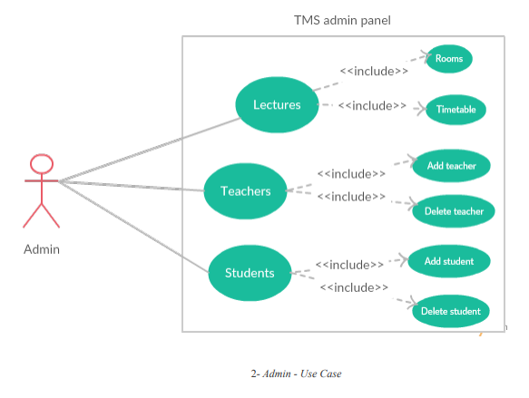

* We have created a student login page

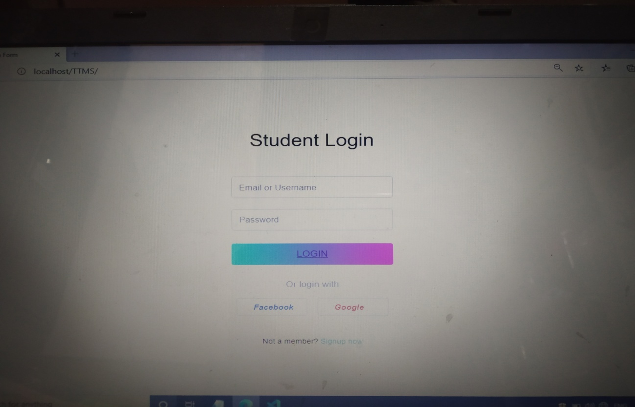

* Created a table of student’s time table using HTML, CSS, JS, and PHP.

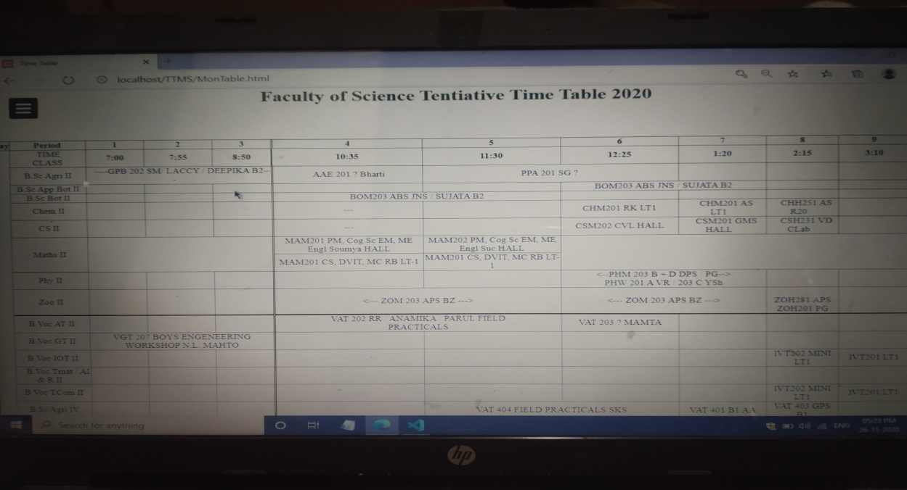

* Created a Pagination bar to saw weekly time table properly

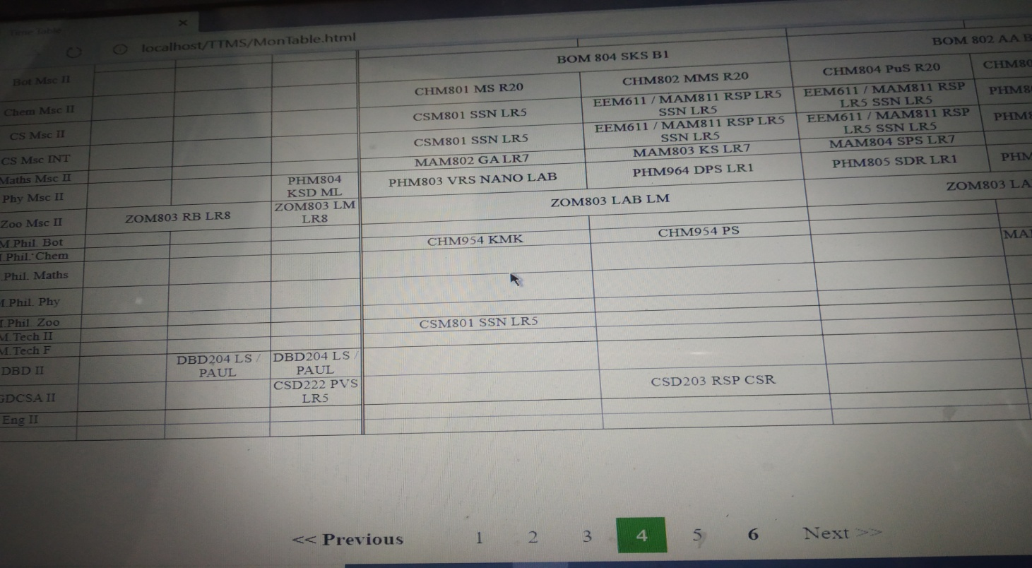

* 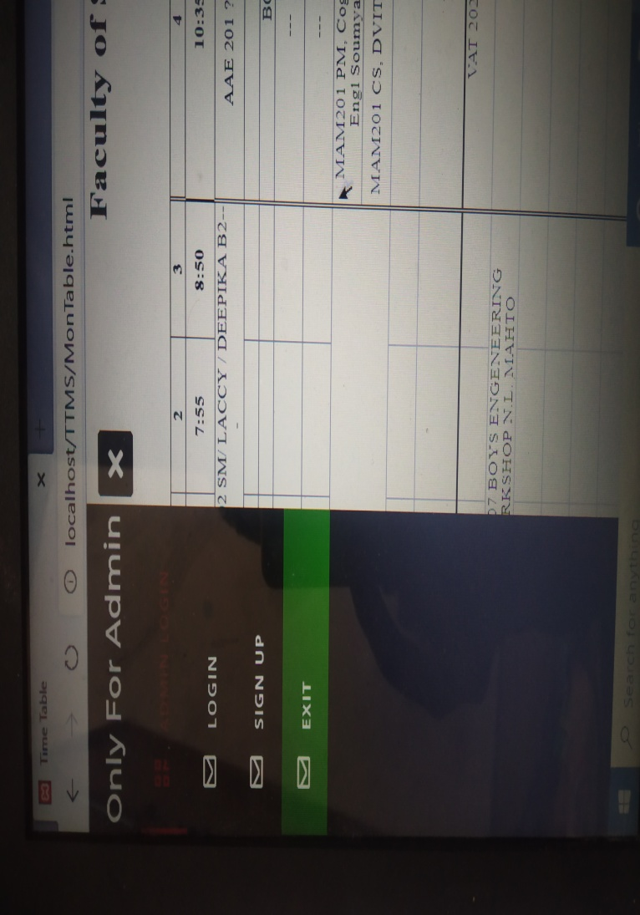Created a Navigation bar for Login Administrator only
* Created a Login / Signup for Administrator only

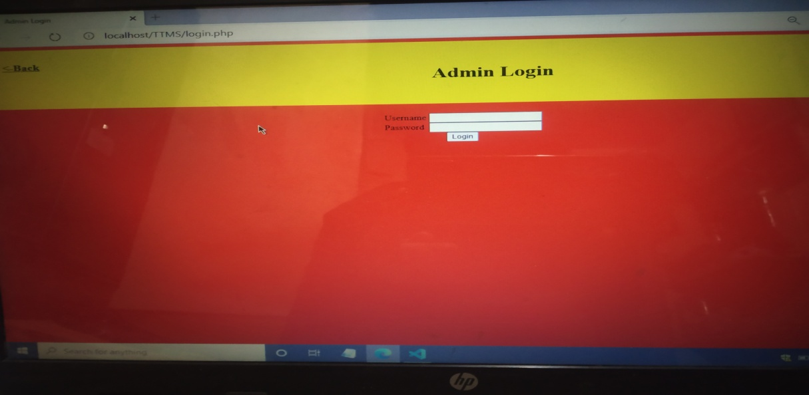

**Advantages:-**

* This project can apply in School, Colleges, Universities, government and private sectors also.
* It can save global warming.
* Easy creation of timetable and can export in Excel format.
* You can create time-slots for the timetable as per your institute requirement.
* You can create different time-slots for different standards as per the need.
* Edit and change time-table as when it needs.
* Students can view their respective class timetable in their smartphone
* Teachers can view their whole week timetable in their mobile application
* Time to time re-arrangement can be done.
* Automatic creation of timetable for teachers on the creation of students’ timetables

**Conclusion:-**

* Student Management System can be used by educational institutions to maintain their student records easily.
* Achieving this objective is difficult using the manual system as the information is scattered, can be redundant and collecting relevant information may be very time-consuming.
* All these problems are solved by this project. This system helps in maintaining the information of pupil of the organization.
* It can be easily accessed by the manager and kept safe for a long period of time without any changes.

**REFERENCES:-**

[1] E. K. Burke, D. G. E lliman, and R. Weare, “A u niversity

timetabling system based on graph colouring and constraint

manipulation,” J. Res. Comput. Educ., vol. 27, no. 1, pp. 1–

18, 1994.

[2] D. Datta, K. Deb, and C. M. Fonseca, “Solving class

timetabling problem of IIT Kanpur using multi-objective

evolutionary algorithm,” KanGAL Rep., vol. 2006006, pp.

1–10, 2006.

[3] J. Lee, S.-P. Ma, L. F. Lai, N. L. Hsueh, and Y.-Y.

Fanjiang, “University timetabling through conceptual

modeling,” Int. J. Intell. Syst., vol. 20, no. 11, pp. 1137–

1160, Nov. 2005.

[4] A. Chowdhary, P. Kakde, S. Dhoke, S. Ingle, R. Rushiya,

and D. Gawande, “TIMETABLE GENERATION

SYSTEM,” Int. J. Comput. Sci. Mob. Comput., vol. 3, no. 2,

2014.

[5] N. Pillay, “A survey of school timetabling research,” Ann.

Oper. Res., vol. 218, no. 1, pp. 261–293, Jul. 2014.

[6] E. K. Burke and S. Petrovic, “Recent research directions in

automated timetabling,” Eur. J. Oper. Res., vol. 140, no. 2,

pp. 266–280, 2002.

[7] B. Paechter, R. C. Rankin, and A. Cumming, “I mproving a

lecture timetabling system for university-wide use,” in

International Conference on the Practice and Theory of

Automated Timetabling, 1997, pp. 156–165.

[8] A. Colorni, M. Dorigo, and V. Maniezzo, “ A genetic

algorithm to solve the timetable problem,” Politec. Milano

Milan Italy TR, pp. 90–60, 1992.

[9] S. Hooshmand, M. Behshameh, and O. Hamidi, “A Tabu

Search Algorithm With Efficient Diversification Strategy

for High School Timetabling Problem,” Int. J. Comput. Sci.

Inf. Technol., vol. 5, no. 4, pp. 21–34, Aug. 2013.

[10] J. J. Moreira, “A system for automatic construction of Exam

Timetable using Genetic Algorithms,” Rev. Estud.

Politécnicos Polytech. Stud. Rev., vol. 6, no. 9, 2008.

[11] Mp. Professor Ashoka Karunananda Bsc. PhD, Artificial

Intelligence, 2004.05. Tharanji Prints, Highlevel Road,

Nawinna, Maharagama, 2004.

Timetables.” [Online]. Available: